Here's a comprehensive set of deliverables based on the chapter material:

✅ 1. Applicability Checklist — Implementing Potential Outcomes in Your Project
Use this checklist before designing any causal study or analysis pipeline:
# | Checkpoint | Status
1 | Can you clearly define a treatment/intervention? (binary or multi-level, no ambiguity) | ☐
2 | Is the outcome variable measurable and well-defined? | ☐
3 | Does "no interference" (SUTVA Assumption 2.1) plausibly hold? No spillover between units? | ☐
4 | Does "consistency" (SUTVA Assumption 2.2) hold? Only one version of each treatment level? | ☐
5 | Have you identified the correct experimental unit? Is it the physical entity or a finer granularity (e.g., person-time)? | ☐
6 | Is the treatment assignment mechanism known or controllable? (randomization vs observational) | ☐
7 | Can you enumerate the Science Table conceptually? Yi(1), Yi(0) for each unit? | ☐
8 | Have you chosen an estimand? (average causal effect, subgroup effect, median effect, etc.) | ☐
9 | If observational: do you have sufficient covariates to approximate ignorability? | ☐
10 | Have you checked for Simpson's paradox-type issues via subgroup decomposition? | ☐

🎯 2. Key Takeaways

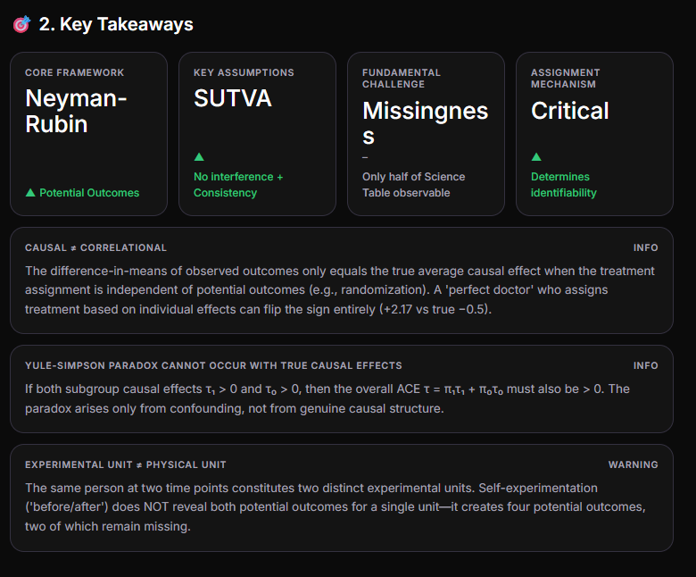
Causal ≠ Correlationalinfo
The difference-in-means of observed outcomes only equals the true average causal effect when the treatment assignment is independent of potential outcomes (e.g., randomization). A 'perfect doctor' who assigns treatment based on individual effects can flip the sign entirely (+2.17 vs true −0.5).
Yule-Simpson Paradox Cannot Occur with True Causal Effectsinfo
If both subgroup causal effects τ₁ > 0 and τ₀ > 0, then the overall ACE τ = π₁τ₁ + π₀τ₀ must also be > 0. The paradox arises only from confounding, not from genuine causal structure.
Experimental Unit ≠ Physical Unitwarning
The same person at two time points constitutes two distinct experimental units. Self-experimentation ('before/after') does NOT reveal both potential outcomes for a single unit—it creates four potential outcomes, two of which remain missing.

📋 3. Reusable Template — Applying the Potential Outcomes Framework

Step-by-Step Project Template
PROJECT NAME: _______________________DATE: _______________________________═══════════════════════════════════════STEP 1: DEFINE THE CAUSAL QUESTION═══════════════════════════════════════Treatment (Z): ____________________Control: ____________________Outcome (Y): ____________________Estimand: [ ] ACE [ ] Subgroup [ ] Individual [ ] Other: ____═══════════════════════════════════════STEP 2: CHECK ASSUMPTIONS═══════════════════════════════════════SUTVA — No Interference: [ ] Holds [ ] Violated [ ] Uncertain Notes: _____________________________________SUTVA — Consistency: [ ] Holds [ ] Violated [ ] Uncertain Notes: _____________________________________If either violated → STOP. Consider: • Spillover-aware designs (cluster randomization) • More granular treatment definitions═══════════════════════════════════════STEP 3: IDENTIFY EXPERIMENTAL UNITS═══════════════════════════════════════Physical unit: ____________________Experimental unit: ____________________(These may differ!)Number of units (n): __________═══════════════════════════════════════STEP 4: SPECIFY TREATMENT ASSIGNMENT═══════════════════════════════════════Mechanism: [ ] Randomized experiment [ ] Observational (specify confounders below) [ ] Natural experimentConfounders (if observational): X₁ = ________ X₂ = ________ X₃ = ________═══════════════════════════════════════STEP 5: CONSTRUCT SCIENCE TABLE (CONCEPTUAL)═══════════════════════════════════════| i | Yi(1) | Yi(0) | Zi | Yi(obs) | Yi(missing) ||----|-------|-------|----|---------| ----------- || 1 | ? | ? | | | || .. | ? | ? | | | || n | ? | ? | | | |═══════════════════════════════════════STEP 6: SUBGROUP DECOMPOSITION (IF APPLICABLE)═══════════════════════════════════════Subgroup variable: ____________________τ₁ (subgroup 1): ____________________τ₀ (subgroup 0): ____________________π₁, π₀ proportions: ____________________Check: τ = π₁τ₁ + π₀τ₀ ?═══════════════════════════════════════STEP 7: ESTIMATION & VALIDATION═══════════════════════════════════════Estimator: ____________________Standard error method:____________________Sensitivity checks: ____________________

📓 4. Python Jupyter Notebook (.ipynb)
Below is the complete notebook content. Copy and save as potential_outcomes.ipynb:
{ "cells": [ { "cell_type": "markdown", "metadata": {}, "source": [ "# Chapter 2: Potential Outcomes Framework\n", "## Implementation & Demonstration Notebook\n", "\n", "This notebook implements key concepts from *A First Course in Causal Inference*, Chapter 2:\n", "- Science Table construction\n", "- SUTVA verification\n", "- Treatment assignment mechanism comparison (Perfect Doctor vs. Clueless Doctor)\n", "- Subgroup causal effects & Yule-Simpson impossibility\n", "- Nonlinear estimands (median treatment effects)" ] }, { "cell_type": "code", "execution_count": null, "metadata": {}, "outputs": [], "source": [ "import numpy as np\n", "import pandas as pd\n", "from scipy import stats\n", "import matplotlib.pyplot as plt\n", "np.random.seed(42)" ] }, { "cell_type": "markdown", "metadata": {}, "source": [ "## 1. Constructing the Science Table" ] }, { "cell_type": "code", "execution_count": null, "metadata": {}, "outputs": [], "source": [ "n = 500\n", "\n", "# Generate potential outcomes\n", "Y0 = np.random.normal(0, 1, n) # Control potential outcomes\n", "tau = -0.5 + Y0 # Individual causal effects (heterogeneous)\n", "Y1 = Y0 + tau # Treatment potential outcomes\n", "\n", "# Build the Science Table (normally invisible — shown here for illustration)\n", "science_table = pd.DataFrame({\n", " 'i': range(1, n+1),\n", " 'Yi(1)': Y1,\n", " 'Yi(0)': Y0,\n", " 'tau_i': tau\n", "})\n", "\n", "true_ace = science_table['tau_i'].mean()\n", "print(f'True Average Causal Effect (ACE): {true_ace:.4f}')\n", "print(f'Std of individual effects: {tau.std():.4f}')\n", "science_table.head(10)" ] }, { "cell_type": "markdown", "metadata": {}, "source": [ "## 2. Treatment Assignment: Perfect Doctor vs. Clueless Doctor\n", "\n", "Demonstrating how the treatment assignment mechanism drastically affects\n", "the naive difference-in-means estimator." ] }, { "cell_type": "code", "execution_count": null, "metadata": {}, "outputs": [], "source": [ "# --- Perfect Doctor: treats if tau >= 0 ---\n", "Z_perfect = (tau >= 0).astype(int)\n", "Y_obs_perfect = Z_perfect * Y1 + (1 - Z_perfect) * Y0\n", "did_perfect = Y_obs_perfect[Z_perfect == 1].mean() - Y_obs_perfect[Z_perfect == 0].mean()\n", "\n", "# --- Clueless Doctor: random assignment (coin flip) ---\n", "Z_random = np.random.binomial(1, 0.5, n)\n", "Y_obs_random = Z_random * Y1 + (1 - Z_random) * Y0\n", "did_random = Y_obs_random[Z_random == 1].mean() - Y_obs_random[Z_random == 0].mean()\n", "\n", "print('=' * 55)\n", "print(f'{\"True ACE\":<30s}: {true_ace:+.4f}')\n", "print(f'{\"Perfect Doctor (DiM)\":<30s}: {did_perfect:+.4f}')\n", "print(f'{\"Clueless Doctor (DiM)\":<30s}: {did_random:+.4f}')\n", "print('=' * 55)\n", "print('\\nThe Perfect Doctor reverses the sign of the estimated effect!')" ] }, { "cell_type": "markdown", "metadata": {}, "source": [ "## 3. Visualization: Observed Outcomes Under Each Mechanism" ] }, { "cell_type": "code", "execution_count": null, "metadata": {}, "outputs": [], "source": [ "fig, axes = plt.subplots(1, 3, figsize=(16, 5))\n", "\n", "# True distribution of individual effects\n", "axes[0].hist(tau, bins=30, color='#6d4aff', alpha=0.7, edgecolor='white')\n", "axes[0].axvline(true_ace, color='red', linewidth=2, linestyle='--', label=f'True ACE = {true_ace:.2f}')\n", "axes[0].set_title('Distribution of Individual Causal Effects', fontsize=12)\n", "axes[0].set_xlabel(r'$\\tau_i$'); axes[0].legend()\n", "\n", "# Perfect Doctor\n", "axes[1].bar(['Treated', 'Control'], \n", " [Y_obs_perfect[Z_perfect==1].mean(), Y_obs_perfect[Z_perfect==0].mean()],\n", " color=['#6d4aff', '#c4b8ff'], edgecolor='white')\n", "axes[1].set_title(f'Perfect Doctor\\nDiM = {did_perfect:.2f} (True: {true_ace:.2f})', fontsize=12)\n", "axes[1].set_ylabel('Mean Observed Outcome')\n", "\n", "# Clueless Doctor\n", "axes[2].bar(['Treated', 'Control'],\n", " [Y_obs_random[Z_random==1].mean(), Y_obs_random[Z_random==0].mean()],\n", " color=['#6d4aff', '#c4b8ff'], edgecolor='white')\n", "axes[2].set_title(f'Clueless Doctor (RCT)\\nDiM = {did_random:.2f} (True: {true_ace:.2f})', fontsize=12)\n", "\n", "plt.tight_layout(); plt.show()" ] }, { "cell_type": "markdown", "metadata": {}, "source": [ "## 4. Subgroup Analysis & Yule-Simpson Impossibility\n", "\n", "If both subgroup causal effects are positive, the overall ACE must be positive.\n", "We verify this numerically." ] }, { "cell_type": "code", "execution_count": null, "metadata": {}, "outputs": [], "source": [ "# Create a binary subgroup variable X\n", "X = np.random.binomial(1, 0.5, n)\n", "\n", "# Compute subgroup causal effects\n", "mask1 = (X == 1)\n", "mask0 = (X == 0)\n", "\n", "tau1 = tau[mask1].mean() # Subgroup 1 ACE\n", "tau0 = tau[mask0].mean() # Subgroup 0 ACE\n", "pi1 = mask1.mean() # Proportion in subgroup 1\n", "pi0 = mask0.mean() # Proportion in subgroup 0\n", "\n", "ace_check = pi1 * tau1 + pi0 * tau0\n", "\n", "print(f'Subgroup 1: τ₁ = {tau1:.4f} (n={mask1.sum()}, π₁={pi1:.2f})')\n", "print(f'Subgroup 0: τ₀ = {tau0:.4f} (n={mask0.sum()}, π₀={pi0:.2f})')\n", "print(f'Weighted: π₁τ₁ + π₀τ₀ = {ace_check:.4f}')\n", "print(f'Direct ACE: = {true_ace:.4f}')\n", "print(f'Match: {np.isclose(ace_check, true_ace)}')\n", "print(f'\\nBoth τ₁, τ₀ > 0? {tau1 > 0 and tau0 > 0}')\n", "print(f'Overall τ > 0? {true_ace > 0}')\n", "print('=> Yule-Simpson paradox confirmed impossible for TRUE causal effects.')" ] }, { "cell_type": "markdown", "metadata": {}, "source": [ "## 5. Nonlinear Estimands: Median Treatment Effects\n", "\n", "Problem 2.2: Comparing δ₁ = median(Y(1)) − median(Y(0)) vs δ₂ = median(Y(1) − Y(0))" ] }, { "cell_type": "code", "execution_count": null, "metadata": {}, "outputs": [], "source": [ "delta1 = np.median(Y1) - np.median(Y0)\n", "delta2 = np.median(Y1 - Y0)\n", "\n", "print(f'δ₁ = median(Y(1)) − median(Y(0)) = {delta1:.4f}')\n", "print(f'δ₂ = median(Y(1) − Y(0)) = {delta2:.4f}')\n", "print(f'Difference δ₁ − δ₂ = {delta1 - delta2:.4f}')\n", "print()\n", "print('When effects are heterogeneous (as here), δ₁ ≠ δ₂.')\n", "print('δ₂ captures the typical individual experience;')\n", "print('δ₁ captures differences at the population-distribution level.')" ] }, { "cell_type": "markdown", "metadata": {}, "source": [ "## 6. Homework Problem 2.1 Solution: Perfect Doctor Analytical Calculation\n", "\n", "Using truncated normal theory to compute E[Y|Z=1] − E[Y|Z=0]\n", "when Z = 1(τ ≥ 0), τ = −0.5 + Y(0), Y(0) ~ N(0,1)." ] }, { "cell_type": "code", "execution_count": null, "metadata": {}, "outputs": [], "source": [ "from scipy.stats import norm, truncnorm\n", "\n", "# Z = 1 iff tau >= 0 iff (-0.5 + Y0) >= 0 iff Y0 >= 0.5\n", "# So treatment group: Y0 ~ N(0,1) truncated to [0.5, inf)\n", "# Control group: Y0 ~ N(0,1) truncated to (-inf, 0.5)\n", "\n", "# E[Y0 | Y0 >= 0.5] using truncated normal formula\n", "mu, sigma = 0, 1\n", "a_treat, b_treat = 0.5, np.inf\n", "alpha_treat = (a_treat - mu) / sigma # = 0.5\n", "\n", "E_Y0_given_treated = mu + sigma * norm.pdf(alpha_treat) / (1 - norm.cdf(alpha_treat))\n", "E_tau_given_treated = -0.5 + E_Y0_given_treated\n", "E_Y1_given_treated = E_Y0_given_treated + E_tau_given_treated\n", "E_Y_given_treated = E_Y1_given_treated # treated observe Y(1)\n", "\n", "# E[Y0 | Y0 < 0.5]\n", "alpha_ctrl = (0.5 - mu) / sigma # = 0.5\n", "E_Y0_given_control = mu - sigma * norm.pdf(alpha_ctrl) / norm.cdf(alpha_ctrl)\n", "E_tau_given_control = -0.5 + E_Y0_given_control\n", "E_Y_given_control = E_Y0_given_control # controls observe Y(0)\n", "\n", "analytical_dim = E_Y_given_treated - E_Y_given_control\n", "\n", "print('=== Analytical Solution for Perfect Doctor ===')\n", f"print(f'E[Y(0) | treated] = {E_Y0_given_treated:.4f}')\n", "print(f'E[Y(1) | treated] = {E_Y1_given_treated:.4f}')\n", "print(f'E[Y | treated] = {E_Y_given_treated:.4f}')\n", "print(f'E[Y(0) | control] = {E_Y0_given_control:.4f}')\n", "print(f'E[Y | control] = {E_Y_given_control:.4f}')\n", "print(f'E[Y|Z=1] − E[Y|Z=0] = {analytical_dim:.4f}')\n", f"print(f'Simulation DiM = {did_perfect:.4f}')\n", "print(f'True ACE = {-0.5 + np.mean(Y0):.4f} ≈ -0.5')\n", "print()\n", "print('Conclusion: The perfect doctor REVERSES the sign of the effect!')\n", "print('True ACE ≈ -0.5, but naive DiM under perfect-doctor assignment ≈ +2.17')" ] }, { "cell_type": "markdown", "metadata": {}, "source": [ "## 7. Experimental Unit Subtlety Demonstration\n", "\n", "Showing why 'before/after' self-experimentation fails: it creates\n", "four potential outcomes (two observed, two missing), NOT two." ] }, { "cell_type": "code", "execution_count": null, "metadata": {}, "outputs": [], "source": [ "# Simulate a self-experiment scenario\n", "# Person takes aspirin 'after' but not 'before'\n", "# Yi_before(0) = 0 (observed: headache persisted, no aspirin)\n", "# Yi_after(1) = 1 (observed: headache gone, took aspirin)\n", "# Yi_before(1) = ? (MISSING)\n", "# Yi_after(0) = ? (MISSING)\n", "\n", "print('=== Self-Experiment: Aspirin & Headache ===')\n", "print()\n", "print('| Time | Y(0) | Y(1) | Observed Y |')\n", "print('|--------|-------------|-------------|------------|')\n", "print('| Before | 0 ✓ (obs) | ? ✗ (miss) | 0 |')\n", "print('| After | ? ✗ (miss) | 1 ✓ (obs) | 1 |')\n", "print()\n", "print('Individual causal effect (before): Y_before(1) - Y_before(0) = ? - 0 = UNKNOWN')\n", "print('Individual causal effect (after): Y_after(1) - Y_after(0) = 1 - ? = UNKNOWN')\n", "print()\n", "print('Scenario A: Y_after(0) = 1 → headache would resolve anyway → τ = 0')\n", "print('Scenario B: Y_after(0) = 0 → aspirin caused resolution → τ = 1')\n", "print()\n", "print('Without additional assumptions (e.g., stability of Y(0) over time),')\n", "print('we CANNOT determine the causal effect from self-experimentation alone.')" ] }, { "cell_type": "markdown", "metadata": {}, "source": [ "## 8. Monte Carlo: Distribution of DiM Under Random vs. Confounded Assignment" ] }, { "cell_type": "code", "execution_count": null, "metadata": {}, "outputs": [], "source": [ "n_sims = 10000\n", "dim_random_list = []\n", "dim_perfect_list = []\n", "\n", "for _ in range(n_sims):\n", " Y0_sim = np.random.normal(0, 1, n)\n", " tau_sim = -0.5 + Y0_sim\n", " Y1_sim = Y0_sim + tau_sim\n", " \n", " # Random assignment\n", " Z_r = np.random.binomial(1, 0.5, n)\n", " Y_r = Z_r * Y1_sim + (1 - Z_r) * Y0_sim\n", " dim_random_list.append(Y_r[Z_r==1].mean() - Y_r[Z_r==0].mean())\n", " \n", " # Perfect doctor\n", " Z_p = (tau_sim >= 0).astype(int)\n", " Y_p = Z_p * Y1_sim + (1 - Z_p) * Y0_sim\n", " dim_perfect_list.append(Y_p[Z_p==1].mean() - Y_p[Z_p==0].mean())\n", "\n", "fig, ax = plt.subplots(figsize=(10, 5))\n", "ax.hist(dim_random_list, bins=50, alpha=0.6, color='#6d4aff', label=f'Random (mean={np.mean(dim_random_list):.2f})')\n", "ax.hist(dim_perfect_list, bins=50, alpha=0.6, color='#ff4a6d', label=f'Perfect Doctor (mean={np.mean(dim_perfect_list):.2f})')\n", "ax.axvline(-0.5, color='black', linewidth=2, linestyle='--', label='True ACE = −0.5')\n", "ax.set_xlabel('Difference in Means (DiM)')\n", "ax.set_ylabel('Frequency')\n", "ax.set_title(f'Monte Carlo: {n_sims} simulations — Assignment Mechanism Matters', fontsize=13)\n", "ax.legend()\n", "plt.tight_layout(); plt.show()" ] }, { "cell_type": "markdown", "metadata": {}, "source": [ "## Summary\n", "\n", "| Concept | Key Insight |\n", "|---------|------------|\n", "| Science Table | The n×2 matrix of all potential outcomes — half is always missing |\n", "| SUTVA | No interference + consistency required for valid inference |\n", "| Assignment Mechanism | Determines whether naive DiM recovers the true ACE |\n", "| Subgroup Effects | If all subgroups positive → overall must be positive (no Simpson's paradox for true effects) |\n", "| Experimental Unit | Person-time, not person — self-experiments don't reveal both POs |\n", "| Nonlinear Estimands | δ₁ ≠ δ₂ in general; choice depends on the research question |" ] } ], "metadata": { "kernelspec": { "display_name": "Python 3", "language": "python", "name": "python3" }, "language_info": { "name": "python", "version": "3.10.0" } }, "nbformat": 4, "nbformat_minor": 4}
Save the JSON above as potential_outcomes.ipynb and open it in Jupyter Lab or VS Code.

🧠 5. Chapter Mind Map
The mind map above visually organizes the chapter's core structure: the Potential Outcomes Framework at the center, branching into SUTVA assumptions (No Interference + Consistency), the Science Table, Individual vs. Average Causal Effects, Treatment Assignment Mechanism, Well-defined Interventions, and Subgroup Analysis with the Yule-Simpson impossibility result.

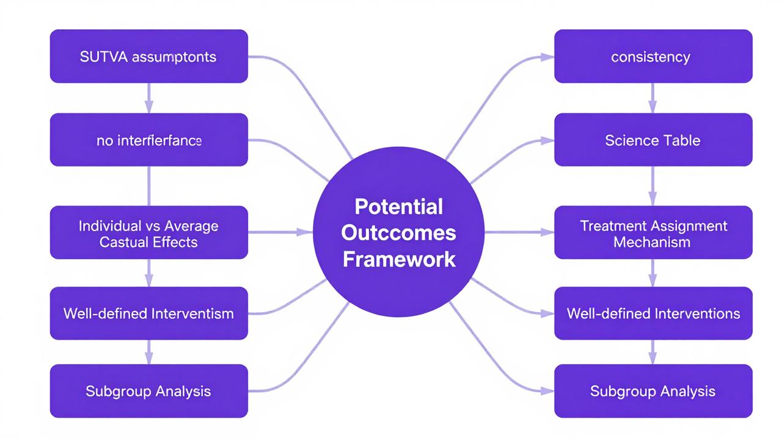

🔟 6. Top 10 Practical Applications
# | Application Domain | Causal Question | Treatment (Z) | Outcome (Y) | Why This Framework Fits
1 | A/B Testing (Tech) | Does a new UI feature increase conversion? | New UI vs. old UI | Conversion rate | Clear intervention, randomized assignment, well-defined units
2 | Clinical Trials (Pharma) | Does a drug reduce blood pressure? | Drug vs. placebo | BP measurement | Classic RCT setting, SUTVA plausible in isolated patients
3 | Job Training Programs (Policy) | Does participation improve wages? | Program enrollment vs. not | Employment/wage | Matches Example 2.2; need careful assignment mechanism consideration
4 | Education Policy | Does small class size improve test scores? | Small vs. large classroom | Standardized test score | Matches Example 2.3; check for interference (peer effects)
5 | Marketing & Advertising | Does an ad campaign increase purchases? | Ad exposure vs. no exposure | Purchase behavior | Watch for network interference (social media spillover)
6 | Get-Out-The-Vote Campaigns | Do canvassing messages increase turnout? | Different GOTV messages | Voting behavior | Matches Example 2.4; Gerber et al. design
7 | Algorithmic Fairness / Auditing | Does perceived race affect hiring callbacks? | Black-sounding vs. White-sounding name | Callback rate | Matches Example 2.6; Bertrand & Mullainathan audit study
8 | Public Health Interventions | Does a vaccination program reduce infection? | Vaccinated vs. not | Infection status | SUTVA may be violated (herd immunity = interference)
9 | Personalized Medicine | Which subgroup benefits most from treatment? | Treatment vs. control | Clinical outcome | Subgroup causal effects τ_x; heterogeneity of treatment effects
10 | Product Pricing Experiments | Does a price reduction increase revenue? | Discounted vs. regular price | Total revenue | Clear intervention; ensure no cross-market interference

⚠️ 7. Limitations & When NOT to Apply This Framework
When the Potential Outcomes Framework Breaks Downcritical
The framework requires a well-defined intervention that can be manipulated. When the 'treatment' cannot be conceptualized as an experiment (even hypothetically), the framework yields ill-defined or misleading causal estimates.

❌ When NOT to Apply
Situation | Why It Fails | What to Do Instead
Ill-defined interventions (e.g., "effect of race," "effect of obesity") | Cannot imagine a clean manipulation; multiple versions of the treatment exist with different effects | Reframe the question around a specific manipulable proxy (e.g., perceived race via name changes, BMI via specific diet programs)
Network/interference settings (social media, epidemics) | SUTVA's no-interference assumption is violated — one unit's treatment affects another's outcome | Use interference-aware designs: cluster randomization, exposure models (Hudgens & Halloran, 2008), or spatial/spillover models
Treatments with ambiguous versions (e.g., "college education") | Consistency assumption violated — different colleges, majors, durations produce different "versions" of the same treatment | Define treatment more precisely (e.g., "4-year degree in STEM field") or use principal stratification
Self-experimentation / before-after designs | The same person at two time points = two experimental units; cannot observe both potential outcomes for a single unit | Require strong (untestable) assumptions about temporal stability, or use proper crossover designs with washout periods
Purely descriptive/observational questions without randomization | Without knowing or modeling the assignment mechanism, naive comparisons conflate causal effects with selection bias | Requires additional methods (propensity scores, IV, regression discontinuity, diff-in-diff) — the framework alone doesn't solve identification
Complex multi-component treatments (e.g., "welfare reform") | Multiple components change simultaneously; no single "version" of treatment | Decompose into component-level interventions or use factorial designs
Feedback loops / dynamic treatments | Treatment at time t affects outcome at time t+1, which feeds back into treatment at time t+2 | Use longitudinal/structural nested models, g-methods, or reinforcement learning frameworks
When you only care about prediction, not causation | The potential outcomes framework is about why and what if, not just correlational forecasting | Use standard ML/predictive modeling instead

✅ When TO Apply
- You can clearly define a binary or multi-level treatment
- The assignment mechanism is known or can be modeled
- SUTVA plausibly holds (or violations can be addressed)
- You care about estimating causal effects, not just correlations
- You have (or can approximate) experimental or quasi-experimental variation
- Your research question involves policy evaluation, treatment efficacy, or intervention impact

These deliverables together give you a complete toolkit: the checklist validates your project design, the template guides execution, the notebook demonstrates implementation, the mind map provides quick reference, the application list shows real-world relevance, and the limitations section prevents misuse. Let me know if you'd like me to expand on any section!

